4D3N DANANG – HOIAN – CAMTHANH – BANA HILLS

DAY 1: DA NANG ARRIVAL - HOIAN ( D )
Arrival Da Nang International airport, meet and greet by our local tour guide. Transfer to Hoian to visit Japanese Bridge, Phuc Kien Communal House, Tan Ky Traditional House, Museum, Handicraftsman at work. Free time for shopping at Hoi An

Meals: 1 Dinner
Accommodation: Overnight in Hoian
The distance: Da Nang - Hoian: 35km – 45 mins for transfer

DAY 2: HOI AN - CAMTHANH – DA NANG (B/L/D)
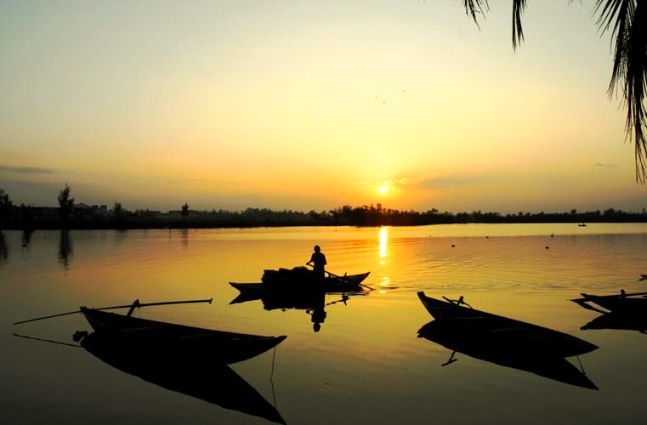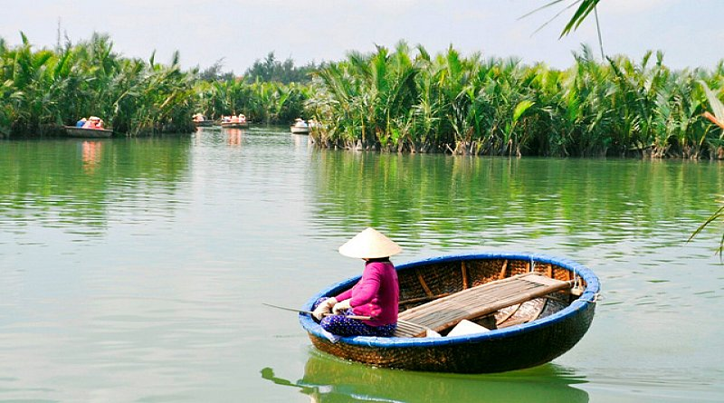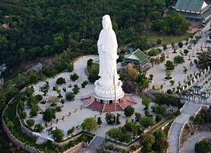
Cam Thanh Coconut Village Linh Ung Pagoda
Breakfast at hotel, transfer to boarding the boat and travelling to Cam Thanh Water Coconut Village. While the boat cruises along the river, observing beautiful Hoi An rural lives with water coconut forest in the background. After that, transfer from the main boat to the bamboo basket boat and slowly rowing to the village and enjoy interesting show. Having an opportunity to learn how to row this unique bamboo basket boat and making an art out of coconut leaves. After lunhc, back to Da Nang, on the way visit Mable Mourtain with Stone Village. Arrival Danang, visit Son Tra Peninsula to admire the beauty of the whole city, with Linh Ung Pagoda.
Dragon Bridge, Love Bridge. Dinner at local restaurant & overnight in Danang.

Meals: 1 Breakfast + 1 Lunch + 1 Dinner
Accommodation: Overnight in Da Nang
The distance: Da Nang – Hoi An: 35km – 45 minutes for transfer
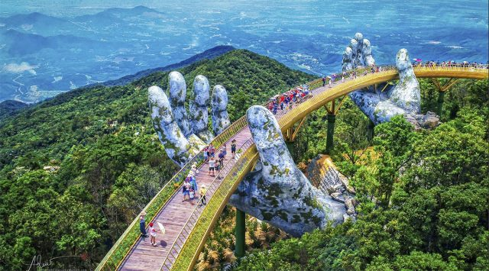
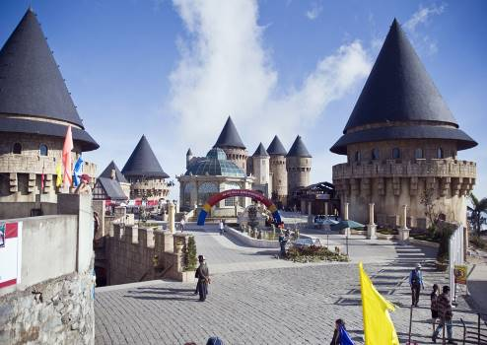
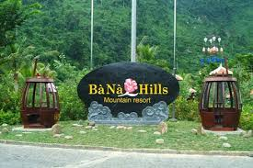
DAY 3: DANANG – BANA HILL (B/L/D)
Bana Hills
After breakfast, transfer to Bana Hills. You have a chance to ride on a modern system of cable cars helps you get a bird's-eye view, very miraculous and attractive. You will visit some old French villas en route, as well as the suspension bridge, Nui Chua & the Mountain Peak (at the height of 1,487m). Visit Vong Nguyet villa where we will visit the wine cellar, Linh Ung Pagoda, Sakyamuni Buddha's monument, Golden Bridge.
Go down to Danang by cable car.

Meals: 1 Breakfast + 1 Lunch + 1 Dinner
Accommodation: Overnight in Da Nang
The distance: Da Nang – Ba Na: 35km – 45 Minutes for transfer

DAY 4: DA NANG DEPARTURE (B)
Breakfast at hotel. Free time until transfer to the airport for flight back home with sweet memories.

Meals: 1 Breakfast
The distance: Da Nang Center – Da Nang Airport : 20km – 30 minutes for transfer.
The ends of program!

SEQUENCE OF ITINERARY SUBJECT TO LOCAL ARRANGEMENT

PRICE INCLUDE:
- Accommodation – as hotel in the list or similar – based on Twin/Double/Triple sharing.
- Tour guide: English or Chinese speaking guide during the tour.
- Daily ABF and meals as mentioned in the program.
- Shows and sightseeing in schedule.
- Transportation by private air-conditioner.
01 bottle ( 500 ml )of drinking water for each pax per day.
- Meals (Vietnamese Food & Chinese Food) as the tour code (B: Breakfast, L: Lunch, D: Dinner) + 1 buffet lunch at Bana Hills
- Sampan in Perfume River in Hue.
PRICE EXCLUDE:
- International / Domestic flight ticket & airport tax (if have).
- Personal expenses: Tel, Fax, Mini Bar, Laundry,etc.
- Personal travel insurance.
- Compulsory Tip for local guide and driver (USD/pax/day)

Group Size | Tips in USD
2 – 4pax | 6
5-7pax | 5
8 - up | 3

- Additional Meal will be surcharge 10usd/pax/meal.
- Surcharge with other languages guide.
- Surcharge at hotel case by case
  - Chinese New Year (TBA).
  - Gala Dinner on X’Mas (24, 25 Dec ) & New Year 31 Dec.
Hotel listed or Similar |  | All rates are next in USD/PAX  valid Jan - Dec, 2020
 |  | Tour by private car / bus with private guide
HUE | DA NANG | 2 | 3-4 | 5-6 | 7-9 | 10-12 | 13-15 | 15+1 | 20+1 | 25 +1 | 30+1 | Sgl up
Thanh Lich 3*  Rosaleen 3* | Queen Finger 3*  King Finger 3*  Royal Charm 3* | 345 | 309 | 255 | 231 | 225 | 208 | 205 | 195 | 185 | 180 | 58
Romance 4*  Asia 4*  Moonlight 4*  Emm 4*  Royal Boutique 4* | Cosmos 4*  Greenery 4*  Aria Grand 4* | 351 | 322 | 275 | 255 | 250 | 236 | 235 | 223 | 215 | 210 | 83

NOTE
The timing of sightseeing points shall be fixing by local operator due to traffic and weather conditions, however all points must cover unless amendment or cancellation make by clients themselves (Non-refundable for any cancellation that made by clients)

Tour and price are subject to change without notice or incase of deduct number of pax in quoted group.

Small deviations in the tour program are sometimes necessary, depending on weather, road conditions, flight schedules and room availability.

Supplement charge for room rate in peak dates depends on the hotel category used. Compulsory gala dinner on X’mas, New Year’s Eve & Lunar New Year’s Eve to be advised upon booking. Prices for group of 15 persons up in 5 stars hotels sometime requires to re-quote bases on the hotel policy

01 FOC for tour leader based on twin sharing basis include breakfast (domestic air ticket is not applicable).

BUS

Group Size | Kind of Transportation
1-2 pax | 4 seater
3 pax | 7 seater
4-9pax | 16 seater
10-18 pax | 30 seater
19-21 pax | 35 seater
22 – 42 pax | 45 seater

CHILD POLICY

- Infant below 2 years old sharing same room with parents is free of charge.
- Child below 12 yrs old sharing same room with 1 ADL is charged for 90%.
- Child below 12 yrs old with extra bed and sharing same room with parents is charged for 65%.
- Child below 12 yrs old No extra bed & sharing same room with parents is charged for 55%

